English Text Effect
CLICK COMPUTER INSTITUTE LUCKNOW U.P. INDIA
CCI LUCKNOW U.P. INDIA
“Accounting & Information Technology School”
CCILucknow U.P. India
Ammonium Sulfate=(NH₄)₂SO₄ (a+b)²=a²+b²+2ab
Sitapur Road Lucknow, India
Sitapur Road Lucknow, India
Sitapur Road Lucknow, India
Click Computer Institute Lucknow U.P. India
Click Computer Institute Lucknow U.P. India
Types Of Computer
- Mini Computer
- Mainframe computer
- Super computer

Types of RAM or ROM
- Types of RAM:
- SDRAM=(Synchronous Dynamic RAM)
- DDR =(Double Data rate SDRAM)
- Type of ROM
- PROM: programmable read only memory
- EPROM: Erasable Programmable Read Only Memory
- EEPROM: Electrically Erasable Programmable Read Only Memory

Cover Page Design

How to create cover page?
- Click on insert menu
- Select cover page option
- Choose your usable option
- Then type your required text.
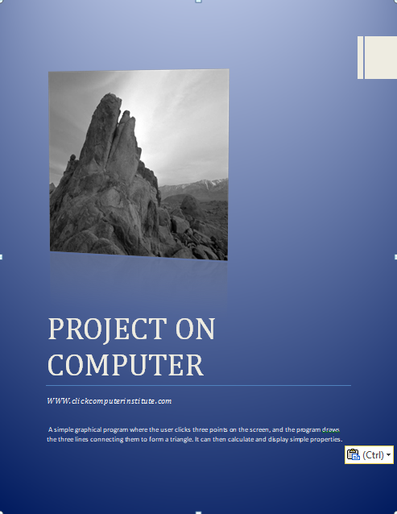

USE TABLE
How to create Bill?
- Click on insert menu.
- Select the table dialog box
- Click on insert table option.
- Define no. of column Eg.5
- Define no of Row: Eg.4
- Click Ok.
- Type your required text in your table.
- First select table and fill your desired color from the design menu-shading
Example
CLICK COMPUTER INSTITUTE
LUCKNOW,U.P.
Bill no. Ph:8299707230
Date:………………
Name: …………………………………………………………………
Address: ……………………………………………………………..
Contact: ………………………………………………………………
S.N | Particulars | Quantity | Rate | Amount
 |  | Total Amount
 |  | Adv. Amount
 |  | Due Amount
Amount in word: ………………………………………………………………………………
……………………..
Signature

Click Computer Institute
Lucknow,U.P.
Result Calculation Sheet
S.n | Name | Full  Marks | Pass  Marks | Subject |  |  |  |  | Total | Result | Percentage | Division | Remark
 |  |  |  | English | Hindi | Maths | Science | Computer
1 | Ram | 100 | 40 | 45 | 75 | 77 | 85 | 80
2 | Vinay | 100 | 40 | 88 | 56 | 80 | 75 | 88
3 | Ajay | 100 | 40 | 96 | 88 | 75 | 55 | 83
4 | Raju | 100 | 40 | 58 | 88 | 89 | 92 | 67
5 | Rohan | 100 | 40 | 66 | 63 | 96 | 99 | 98
6 | Ramesh | 100 | 40 | 88 | 89 | 87 | 78 | 77
7 | Sobhit | 100 | 40 | 82 | 87 | 77 | 78 | 88
8 | Rajan | 100 | 40 | 78 | 77 | 75 | 74 | 77
9 | Rakesh | 100 | 40 | 52 | 88 | 75 | 80 | 90
10 | Manoj | 100 | 40 | 88 | 89 | 87 | 77 | 78

Air Ticket
From: Delhi to Lucknow
 | A | B | C | D | E | F | G | H | I | J | K
1 | Date | Flight  Time | Flight  No. | Last  Name | First  Name | Status | Age | Total  Fare | Discount | Discount  Amount | Net  Fare
2 | 04/15/2012 | 10:20 | SA 125 | Sharama | H | M | 28 | 2500 | 5% | ? | ?
3 |  | 3:20 | GA 1030 | Raunak | K | F | 30 | 3000 | 5% | ? | ?
4 |  | 7:20 | KS 3060 | Amit | K | M | 50 | 6000 | 5% | ? | ?
5
6 | 04/20/2012 | 11:15 |  | Jagan | L | M | 38 | 4000 | 5% | ? | ?
7 |  | 2:20 |  | Manohar | R | M | 40 | 3000 | 5% | ? | ?

Calculation:
- Discount Amount: Total Fare*5%
- Net Fare: Total fare- Discount Amount


STUDENT IDENTITY CARD
CLICK COMPUTER INSTITUTE
AZIZ NAGAR MADIYAON LUCKNOW U.P.
CONTACT NO:+91-8299707230
Name: _________________________________________
Gender: ________________________________________
Shift No: _______________________________________
Course: ________________________________________
DOB: __________________________________________
Contact No: ____________________________________
CLICK COMPUTER INSTITUTE
LUCKNOW,U.P.
Photo
Signature
Name:……………………………………………….
Course: ……………………………………………..
Contact No: ……………………………………….
Blood Group: …………………………………….
Logo Design : Insert Shape

CLICK COMPUTER INSTITUTE
EDUCATION IS LIFE
+
+

GUIDE BOOK




MS word Book

Click Computer Institute
Address: Aziz Nagar Madiyaon Lucknow,U.P., India
Ph: +91-9455668923
Gmail:clickcomputerinstitut@gmail.com
Web: www.clickcomputerinstitute.com


Click Computer Institute
Aziz Nagar,Lucknow
Date:………………….

www.clickcomputerinstitute.com clickcomputerinstitut@gmail.com
Aziz Nagar Madiyaon Lucknow Mob: 8299707230

PROFITABILITY ANALYSIS OF SHARE SAHARA INDIA
MULTIPURPUSE
CO-OPRETIVE LIM ITED
NEW DELHI-INDIA

A project Work Report

Submitted By
Ram Kumar Kanujiya
B.Sc 4th Year
Roll no: 123456
Registration No:7-25-01-1256
New Delhi, India

Submitted to:
Office of controller of Examination
Faculty of Management
Delhi University

In partial fulfillment of the requirement for the degree of
Bachelor of Science
January,2025

MICROSOFT OFFICE
WORD
EXERCISE BOOK

CLICK COMPUTER INSTITUTE
Education is Life
www.clickcmputerinstitute.com
clickcomputerinstitut@gmail.com
Aziz Nagar Madiyaon Lucknow
Phone No: +91-9455668923

Organization Structure: Insert- SmartArt-Hierarchy

Course Detail in Pyramid Shapes: Inser-SmartArt-Pyramid

USER OF OPERATING SYSTEM: INSERT-CHART

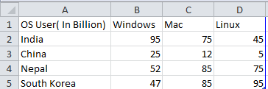

Sales: Insert-chart-pie

